Banyule District Cubs Founders Day 2019
District Bike Ride

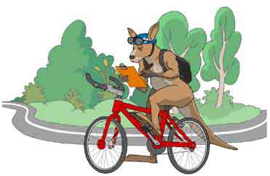

Sunday 24^{h} February 2019
Meeting time 10.30
Riding from:
CT Barling Reserve
Entry from the City or Southbound side of Plenty Road
Reservoir
Riding to:
10th Ivanhoe Scout Hall (This is the old 2nd Ivanhoe Scout Hall )
Wallace St Ivanhoe
We will have a sausage sizzle.
No charge for the sausage sizzle
Cubs collection at 1.30 pm
Please Park Cars in the nearby Coles Car Park - it is a short walk to the Scout Hall in Wallace St, as the entry to and parking at the Scout Hall is limited.

Cubs wear uniform and helmet
- Caremonkey form acceptance is required.
Please pack:
- Snacks
- Water bottle
- Medications
- Health form (Caremonkey printout or Medical/Health form from http://rosannacubs.org/paper.htm )
- Sunblock / insect repellent
No Scooters or bikes with training wheels

Adult/Youth Helpers are welcome to attend
For Catering & Safety Purposes:
PLEASE RESPOND with names to Wayne (Akela) ASAP:
akela@rosannacubs.org
by
RSVP Friday 15th February 2019:

